Minutes of Eight Board Meeting

The eighth board meeting of the directors of Elm Community Charter School was held via Google Hangouts video conference call on April 26, 2018 at 8:00 p.m., pursuant to notice by Chris Kong, board president, setting forth the time and place of the meeting, and emailed to each of the other directors at least one week before the date of this meeting. Written notice was also mailed to all directors at least one week before the date of this meeting. The meeting’s agenda, prior meeting’s minutes, and additional reading materials were sent to board members prior to the start of the meeting.

ATTENDED VIDEO CONFERENCE | DID NOT ATTEND VIDEO CONFERENCE
Debbie Thomas | Redd Sevilla
Saffiyah Madraswala | Chris Kong
Karishma Desai | Anupa Jacob
Lawrence Zhou
Michael Dorcelly
Grace Yun
Brenda Frias
Prijo Thomas
Priscilla Walton *

The above are all the directors of Elm Community Charter School (ECCS).

*Priscilla Walton, the school’s Founder and Principal, is a non-voting board member.

All persons participating in the Google Hangout video conference call meeting were able to hear each other at the same time. Directors were presented with the same materials via email prior to the start of the meeting.

Meeting notes. Board resolutions are shown in bold.

1) Motion to approve minutes from Elm CCS Board Meetings 006 and 007.
Board unanimously approves.

2) Motion to approve Elm CCS Code of Ethics.
Typo found - Section 11 should be dropped to new paragraph.
Motion approved, with edit recommendation above.

3) Motion to approve Elm CCS Benefits Package.
Board unanimously approves.

4) Lottery & enrollment update:
- Over 600 applications. 4 families showed. Time was used to contact families.
- Over 30 of 50 seats, per grade (K-1st), have already begun registration.
- Only 17 acceptance from waitlist left to be filled.
- Families on waitlist actively calling to inquire about possibility child getting a seat.
- There is no concern as to whether seats will be filled come August.
- Families are still continuing to apply.

5) Hiring update:
- Lead, associate, and one creative teachers confirmed.
- Salaries are subject to increase as the years progress.
- Still in need of Visual Art and Shop teachers. Low frequency of applications.
- Spanish & Phys.Ed. vacancies still need to be filled.
- Social Worker and Operations Associate vacancies still need to be filled.
- Board Members will continue to share Elm CCS job openings amongst personal networks.

6) Board checklist:
- Elm CCS is in good standing with board mandates as of now.
- Employee Handbook complete; it is to be reviewed at next meeting (goal).
- 2019 budget complete; it is to be reviewed at next meeting (goal).
- Recommendation: having financial data presented in various formats (ex: simplifying what is presented, or looking at very specific financial data each meeting)

7) Academic Committee Update:
- Elm CCS will use LEAP model (from Denver Public Schools) as primary document to influence its own teacher-evaluation tool
- Academic Committee still pushing on ensuring that intentionality around inquiry is always present
- Measures of evaluation and support for Priscilla is to be presented in future meetings
- Potentially use LEAP model to move towards merit (financial)-based rewards system for teachers
- Non-quantitative metrics (i.e. “Student Voice”) to be evaluate via surveys, one-to-one questioning and conversations with students about coursework, etc.

8) Facilities update:
- Lease negotiation for short-term space: Facilities committee returned lease with some concessions on 4/26. Landlord wants to remove janitorial services from the lease. We are negotiating for a $45K decrease in rent for years 1 and 2.
  - Lease should be signed by end of 1st week of May
- Elm CCS attorney will provide comments on Civic Builders loan (for security deposit).
  - Loan application suggested to be submitted *after* signed leased.
- William Vitacco Associates was hired to perform the work related to the required Certificate of Occupancy update for the temporary space.
- We will be hiring contractors for electrical, carpentry (sheetrock), and mechanical (HVAC) work. We will place a preference for M/WBE contractors (minority and women owned businesses).

9) Finance Committee Update:
- March Financials: some monetary amounts from FY 2019 moved up into FY 2018.
  - This does not affect overall Elm CCS budget
- Between April 2018 & June 2018: expected $387K to be spended
  - $308K can be spent until June; the remainder must be spent by end of FY 2018
- Agreed Upon Procedures Report (by Schall & Ashenfarb Public Accountants, LLC)
- audit determined all financials are in order
- Office Manager will be needed to keep track of checks, receipts, wire-transfers, etc. as Elm CCS develops
- Board will consider plan for reaching out to networks to bring in more funds for Elm CCS.

20) Motion to adjourn meeting.
Meeting adjourned at 9:38 PM.

_______________________________
Michael Dorcelly, Secretary

Materials presented during the meeting (emailed to board members prior to start of meeting): April 28, 2018 - 8:00 p.m.
________________________________________________________________________________________________________________

I) MEETING AGENDA

- Logistics
  - Approvals
    - Approve meeting 6 & 7 minutes
    - Code of Ethics
    - Benefits Package
- Updates
  - Update on Lottery (Priscilla)
  - Update on Enrollment (Marie)
  - Staff Recruitment Update (Priscilla)
    - Staff Update (please delete below when writing the minutes
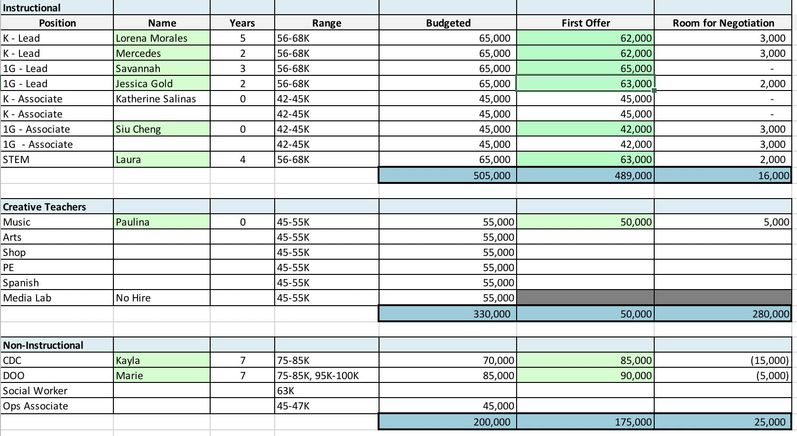
- Review Board Checklist
  - https://docs.google.com/spreadsheets/d/1X6Hn67L5YPA40V5bfWOO6ieUgoLYpvYPG_moEkRjfoU/edit#gid=980958076
- Academic Committee Updates
  - Framework for Effective Teaching (Karishma)
- Facilities Update (Lawrence)
  - Update on Lease Negotiations
  - Update on Loan Agreement with Civic Builders
  - Update on C of O
  - Update on Building Work

- Finance Committee Presentation (Anupa)
  - March Financials
  - AUP Report Issued & submitted to SUNY
  - 2018 Budget review

